1. Laravel Installation

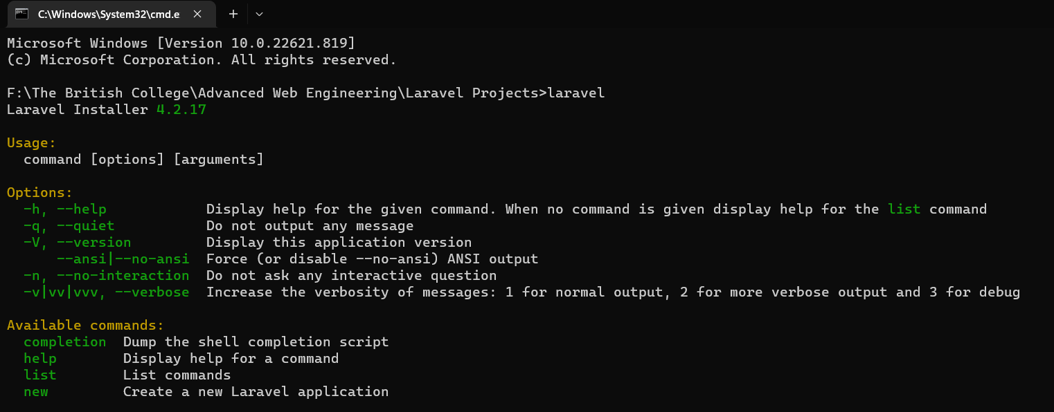
Fig 1: Laravel Installed in PC

2. Laravel Routing

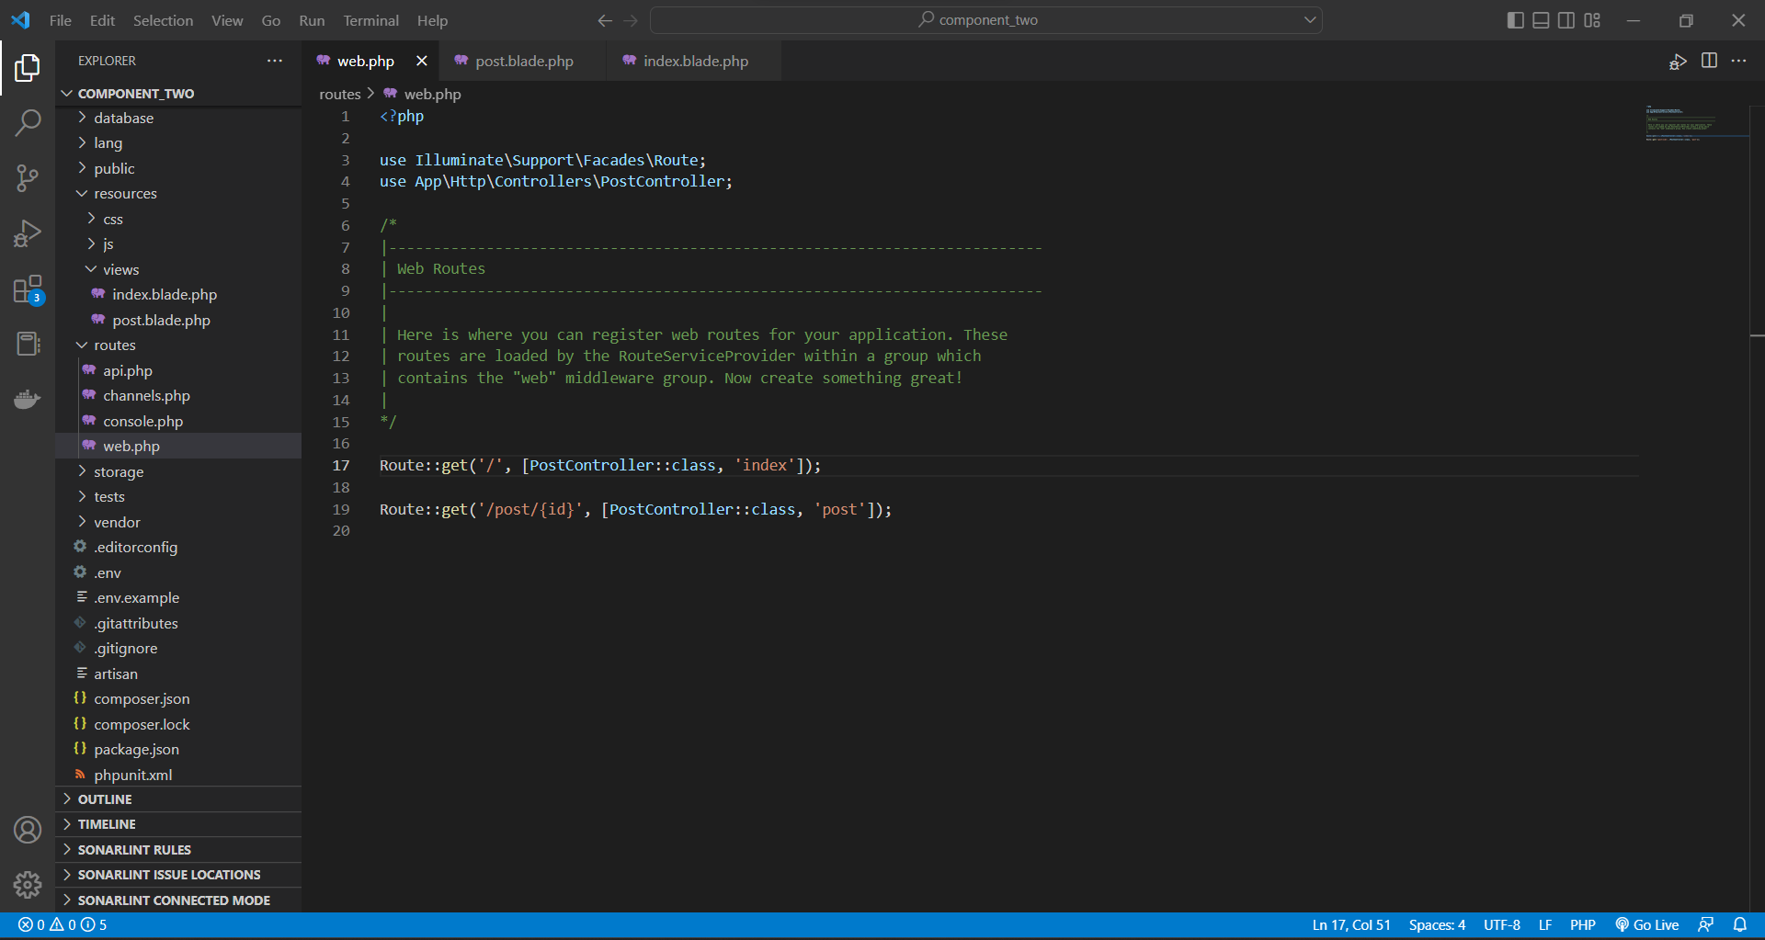
Fig 2: Routes in web.php

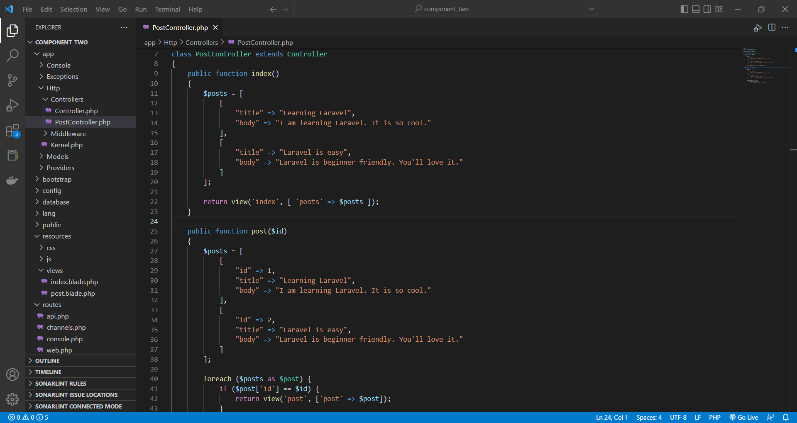
Fig 3: Controller for web.php

3. View Templates

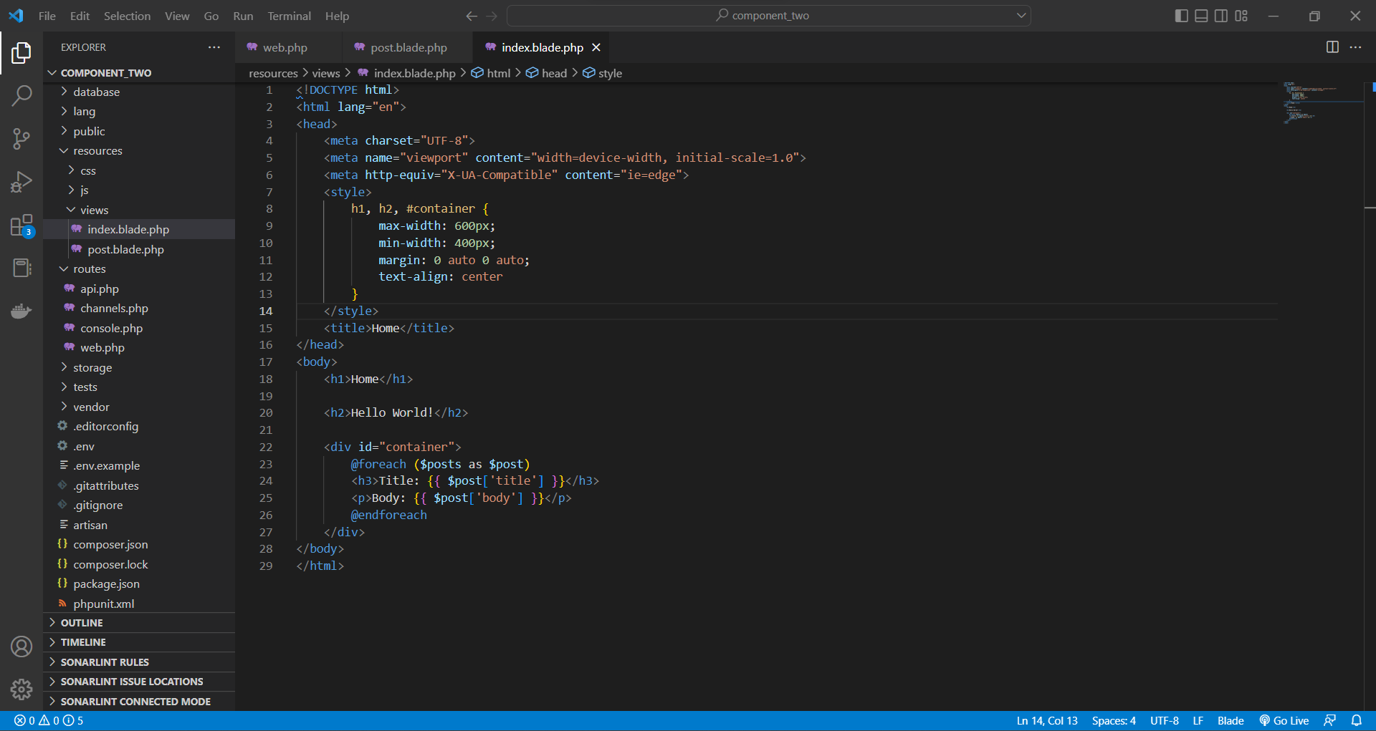
Fig 4: Index view tamplate

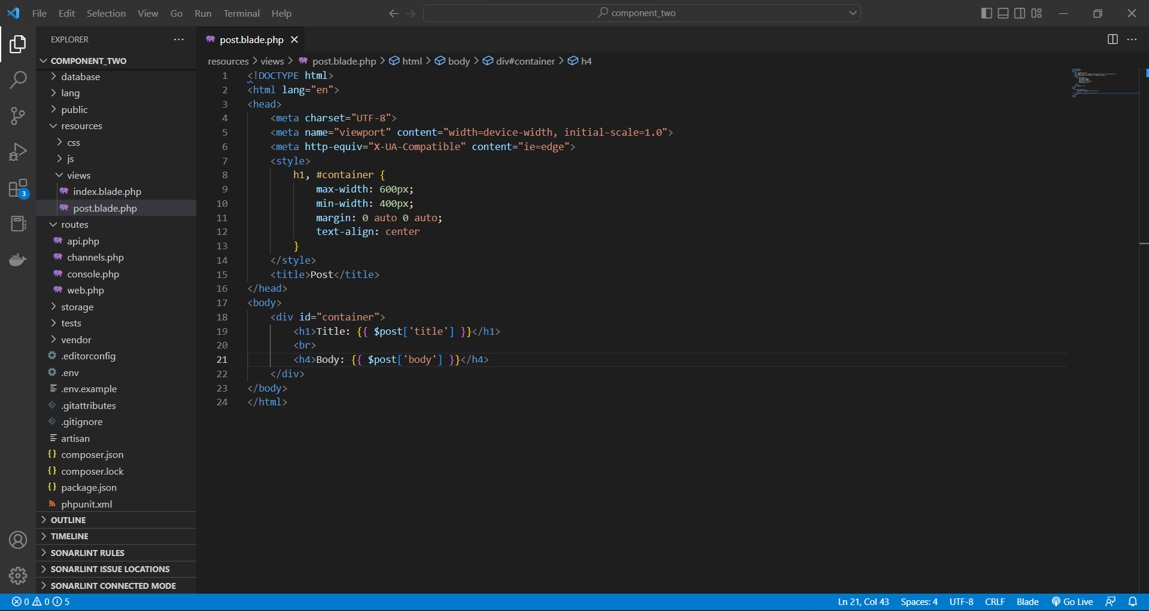
Fig 5: Post view template

4. HTTP Requests (GET, POST, PATCH/PUT, DELETE)

Fig 6: GET HTTP Requests

